<ol type= “ 1 or A or a or I or I” start =”number” >
<ul type =“disc or square or circle” >|
Table
<table border="1">
<caption>Student's table</caption>
<thead>
<tr>
<th>Name</th>
<th>Roll No .</th>
<th>Course</th>
<th>Subject</th>
<th>mark</th>
</tr>
</thead>
<tbody>
<tr>
<td rowspan="4">Anu</td>
<td rowspan="4">12</td>
<td rowspan="4">BCA</td>
<td>Maths</td>
<td>50</td>
</tr>
<tr>
<td>Science</td>
<td>52</td>
</tr>
<tr>
<td>python</td>
<td>52</td>
</tr>
<tr>
<td>Jaava</td>
<td>52</td>
</tr>
</tbody>
</table>
We do rowspan to merge two rows for eg all the marks given here are anu’s marks, in order to not fill null values we use rowspan
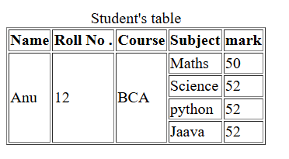
<tr>
<td colspan="4" align="right/>Total Marks :< /td>
<td>102</td>
</tr>
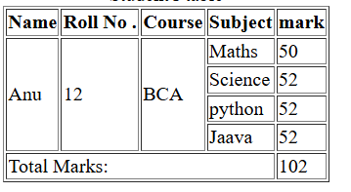

<a href="#h1">Top</a>
In this give an id to an element , and juts click Top to access it by putting “#id”

